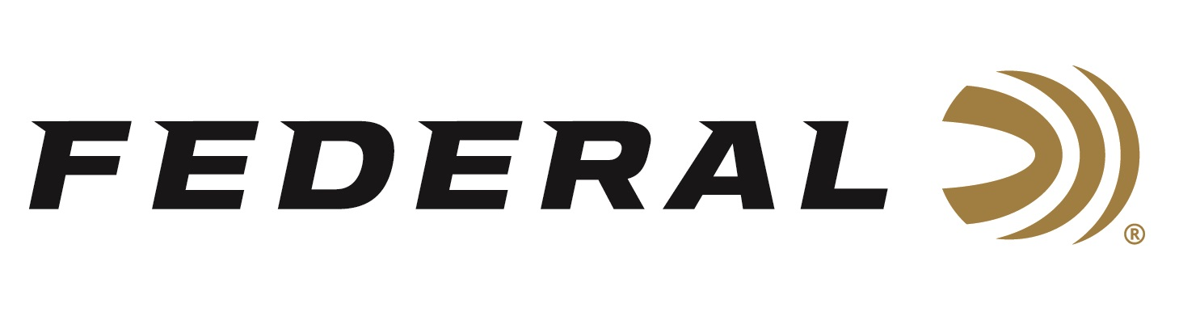

FOR IMMEDIATE RELEASE

Federal and Speer Ammunition Awarded Prestigious FBI Contracts

ANOKA, Minnesota – January 4, 2022 – The FBI awarded Federal and Speer Ammunition in all four categories of its handgun ammunition bid. This prestigious award keeps35,000 employees trained and ready for duty. Three of the rounds will be manufactured in the Anoka, Minnesota facility and the other will be built in Lewiston, Idaho.

Federal and Speer were the only brands to be collectively awarded in all four ammunition categories: Service (Full Size), Service (Micro), Reduced-Lead Training, and Frangible. Federal and Speer were the primary for the Training and Frangible rounds with secondary designations for the full size and micro service rounds.

“It is an honor that our brands continue to be selected for use by the most trusted law enforcement agency and value the products we make,” said Federal’s President Jason Vanderbrink. “The ongoing validation of the technology and performance found in every round of ammunition made by our highly skilled American workforce brings great pride to our company.”

This Indefinite Delivery, Indefinite Quality contract is a one-year base contract with four possible option years. “We are excited to build the FBI the best bullets on the market for both duty and training,” said David Leis, Federal and Speer’s Vice President of Law Enforcement, Government and International Sales. “This is a win for our engineering team as the FBI will be utilizing new as well as refined bullet technology in their firearms for both service and training.”

Federal ammunition can be found at dealers nationwide or purchased online direct from Federal. For more information on all products from Federal or to shop online, visit www.federalpremium.com. For information on Speer visit www.speer.com.

Press Release Contact: JJ Reich
Senior Manager – Press Relations
E-mail: VistaPressroom@VistaOutdoor.com

About Federal Ammunition
Federal, headquartered in Anoka, MN, is a brand of Vista Outdoor Inc., an outdoor sports and recreation company. From humble beginnings nestled among the lakes and woods of Minnesota, Federal Ammunition has evolved into one of the world's largest producers of sporting ammunition. Beginning in 1922, founding president, Charles L. Horn, paved the way for our success. Today, Federal carries on Horn's vision for quality products and service with the next generation of outdoorsmen and women. We maintain our position as experts in the science of ammunition production. Every day we manufacture products to enhance our customers' shooting experience while partnering with the conservation organizations that protect and support our outdoor heritage. We offer thousands of options in our Federal Premium and Federal® lines-it's what makes us the most complete ammunition company in the business and provides our customers with a choice no matter their pursuit.

